**Summary of Country Activities from Sao Tome and Principe 2014/2015**

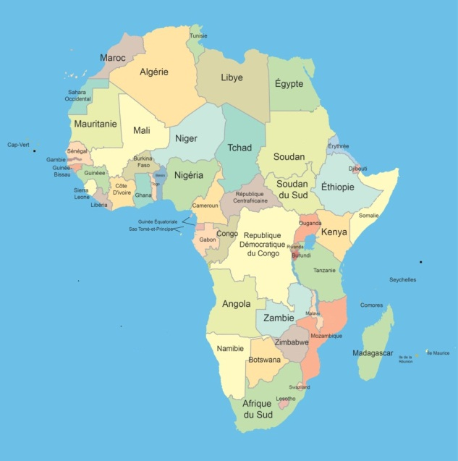

The information published here remains the responsibility of the direction of the planification and educative innovation of the Ministry of the Education, Culture and Science.

|  |
| --- |
|  |

|  |  |  |  |  |
| --- | --- | --- | --- | --- |
|  | **SAO TOME AND PRINCIPE** | | **Central Africa**  CEEAC, Cen-Sad | Area  **1.001** km2 |
| **Sao Tome** | | population  **202.00** inahabitants | Annual Budget |
|  | |

|  |  |  |  |  |  |  |  |
| --- | --- | --- | --- | --- | --- | --- | --- |
| Population % | | | | |  | Budget | |
| Age | General Distribution | | Enrolled by cycle | | School Cycle | % |
| **M** | **F** | **M** | **F** |
| 0 - 3 |  |  |  |  | Pre-primairy | 8,34 |
| 3 - 6 | 8837 | 8823 | 4062 | 4406 | Primary | 10,83 |
| 6 - 12 | 15235 | 15235 | 15236 | 14734 | Secondary | 16,16 |
| 12 - 18 | 12582 | 12366 | 10856 | 11216 | Higher | 13,66 |
| 18 - 25 | 10637 | 10455 | 2125 | 1847 | TVET | 4,76 |
| 25 - 35 |  |  |  |  |  | STI |  |